Wrapping up Chapter 3

Plotting RMR~Ionocytes with CO2 and Temperature color coding showed that temperature is primarily driving the correlations. High temperature has higher RMR in both stages, but in embryos the highest temperature has the LOWEST ionocyte density and in hatchlings the highest temperature has the HIGHEST ionocyte density. So RMR decreases as ionocyte density goes up in embryos because those at lower temperatures have more ionocytes – maybe from having more time to develop? But the ionocytes are evidently not a major source of energy (or oxygen) demand.

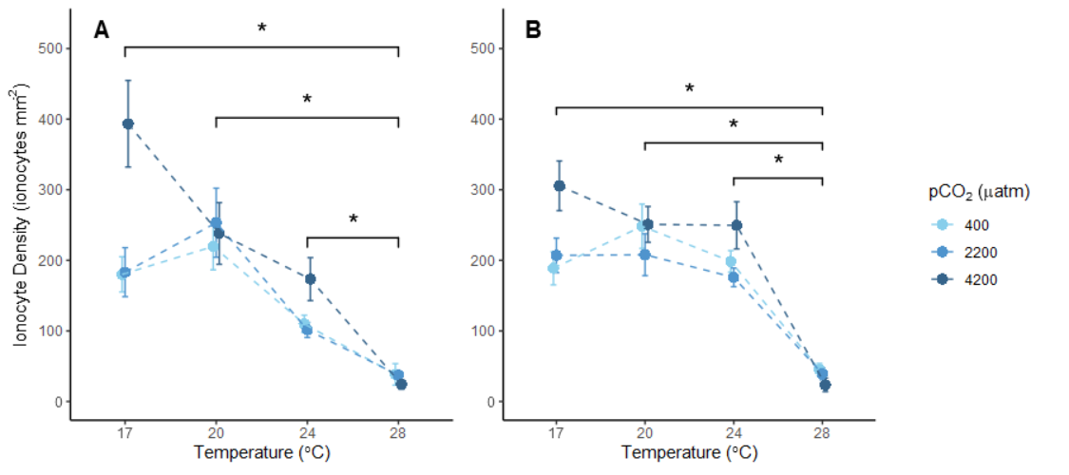

Embryos

-Significant temperature effect

-Increase with CO2 at 17C only

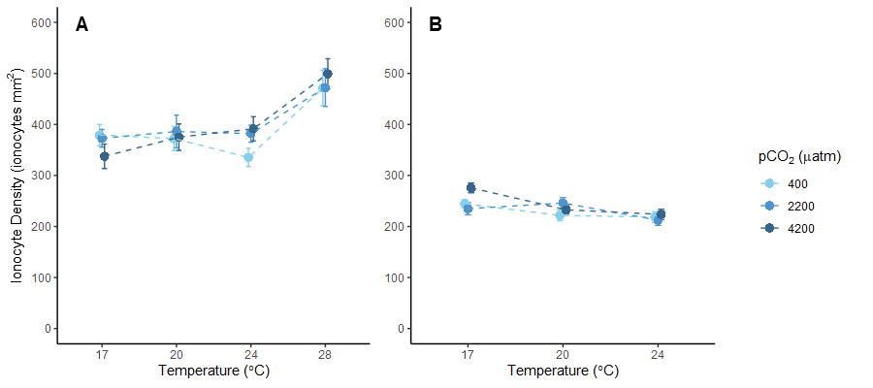

Larvae

-Significant increase with temperature at 1dph

-Increase with pCO2 at 24C in 1dph only

-No significant effects at 10-mm.

Janet’s comments about the discussion:

“I think there are two interesting things that you need to investigate. 1) is the skewed distribution of the embryos that then becomes normal. This suggests to me that only a few embryos have a lot of ionocytes. Maybe a lot of those embryos with not enough ionocytes die, making significant effects in the embryo stage, but the weak have already been picked off by the time they get to the larval stage. Can you show me a distribution(density plot) of ionocytes for the different life stages? Not sure if it’s important to have separated out by treatment

2) is the relationship with respiration. Not sure if the correlation is because of the treatments, but it seems like in the embryos they don’t have enough energy to make ionocytes, hence the negative correlations, but as larvae the RMR indicates that the ionocytes are doing something.”

-make the table of survival and growth effects in each experiment so I can use that to discuss the change in dist before and after hatching (i.e. was it matched by a large die off, and was survival worse in high co2 which would lead to the survivors being OA-tolerant.)

-hatch survival was pretty high and not affected by CO2 except in the 28C experiment, which had lower overall survival and a complex interaction. At 28C survival was overall lower regardless of CO2, but at 24C survival was much lower in extreme pCO2. This suggests low proportion died off at hatching but we don’t know if these were the ones with more or less ionocytes, and at higher temperature when they had less ionocytes mortality was worse.

-More mortality at 28C suggests it was too stressful/costly and the ones that weren’t able to produce ionocytes died, ones that were survived because after hatching 28C has highest ionocyte density.

-One case where mortality was greater because of OA, which was at 24C and suggests they used too much energy on acid-base balance or they didn’t form enough ionocytes prior to hatching for sufficient acid-base balance.

|  |  |  |  |  |  |  |  |
| --- | --- | --- | --- | --- | --- | --- | --- |
|  | Embryo ionocytes | Hatchling ionocytes | Hatch survival | Hatch length | Larval survival | Larval growth | Reference  numbering |
| Exp. 1 | – | × | – | – | ↑ | ↑ | ‘Exp. 2’ |
| Exp. 3 | ↓ | ↓ | – | × | ↑↓ | ↑ | ‘Exp. 3’ |
| Exp. 4 | ↓ | – | – | ↑, ↓, × | ↓ | ↑ | ‘Exp. 5’ |

What do I want to say about the distribution shifting after hatching:

-Hatching brings about a rapid increase in ionocyte abundance, either because they simply develop further or because the ones with fewer ionocytes die.

-Either way the ones that survive hatching are less sensitive to temperature and CO2.

-This also shows the benefit of variability in ionocyte production – some fish developed more ionocytes and can